**Configuring**

**RAID &**

**VMware**

By: Ruben Thomas Y. Reyes III

Date: 11/06/2023

**Setting up RAID In BIOS:**

The first thing to do when setting up RAID is to go into the BIOS section. The equipment in the lab uses Dell R730xd Edge and to boot it **one must plug in a monitor and keyboard into the Dell R730xd Edge** and launch the BIOS section which is during the boot sequence. Wait around 24 seconds in the boot sequence and press the key **“CTRL +R”** this would launch the PERC configuration utility and here we could configure all sorts of stuff including RAID levels for the hard drives. 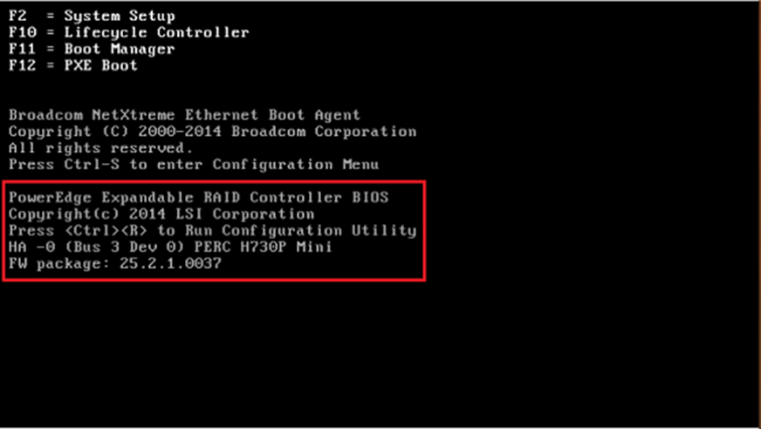

When user is inside PERC configuration utility there are multiple sections, and we want to choose the virtual management page which is under a shorter word **“VD mgmt”** there should be a list of disks that are under virtual disks or physical disks and if there are none then this means that the disks in the server or computer have no hard disks, or they could be broken. If disks are present, then we can configure the disk to the desired RAID level. Under the “VD Mgmt” page if there is a current disk group that has a RAID level that is not desired then we must **delete it by selecting the existing disk group and pressing the “F2” key to access the option to delete it.** 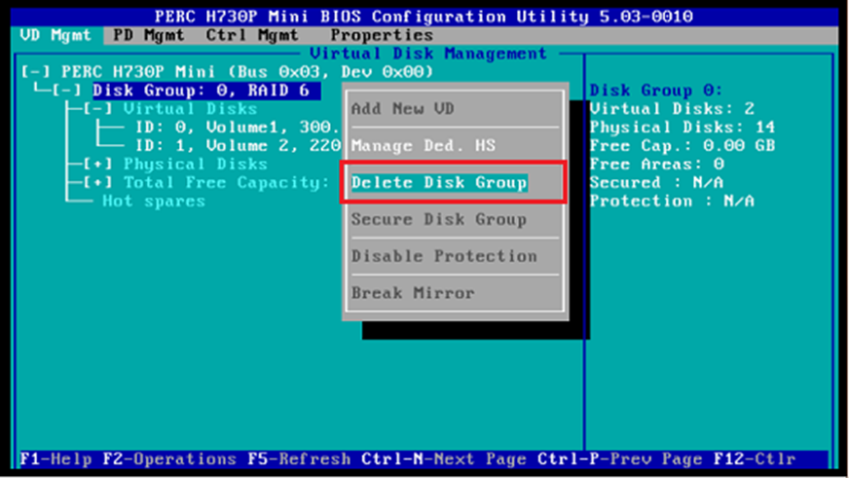

Once we delete it, we can create a new disk group which is under the virtual disk management page. To do this the user must select the RAID controller and press the **“F2” key again to access the options that would allow the user to add a new disk group.** The page will now bring you to the virtual disk management which in we can now select our raid levels for our desired disk group.

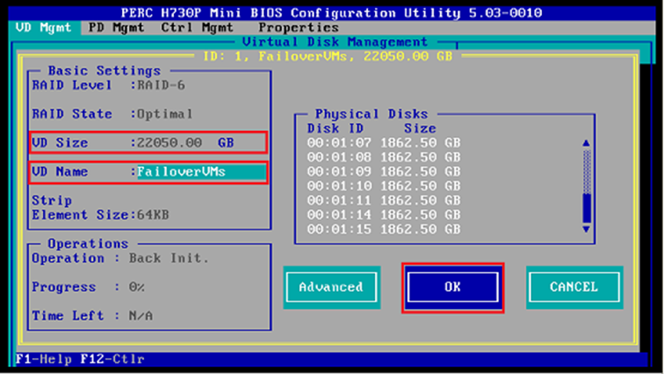

In this section we can now configure our disk group and choose what physical disks are going to be involved in **depending on the RAID level a user decides on (ask a Professor if you do not know).** Users can enter a desired size and the name for the disk group and once the user is done configuring the disk group with the desired RAID level then they can press the “OK” button to finalize the configuration.

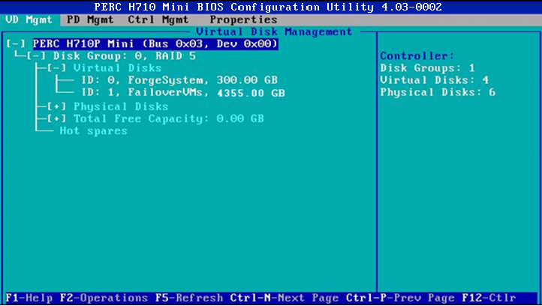

Then the page would go back to the **“VD Mgmt” section and show the user the disk group’s desired RAID level and what space they have.** The example above shows RAID level 5, but this would look different if they have a different desired RAID level.

**Installing VMWare and Configuring DNS and Network:**

To install VMware **one must download the server on the VMware website, but professors in the lab could provide users a copy in the flashdrive so that you may be able to boot VMWare in the server Dell R730xd.** To start off the users must boot the downloaded image file in the flash drive and after that the user must pick the ESXi standard installer during the boot phase to install VMWare ESXi. Once this is done it will continue to install and usually this will take up a couple of minutes. When this is done there are a few questions that it asks a user and these are questions regarding accepting end user license agreement and users must click accept and continue to proceed. The next process is choosing the hard disk to install ESXi server and once that is done users may proceed by clicking continue. The next step is creating a password then after that the user could proceed by clicking continue. The next thing that it asks the user for confirmation of installation and users could just click on continue. After setting up the configuration involving the installation of VMWare the software will ask for a reboot and we should proceed with the process. This concludes the installation of VMWare and the next phase would be configuring the network and the DNS of the server.

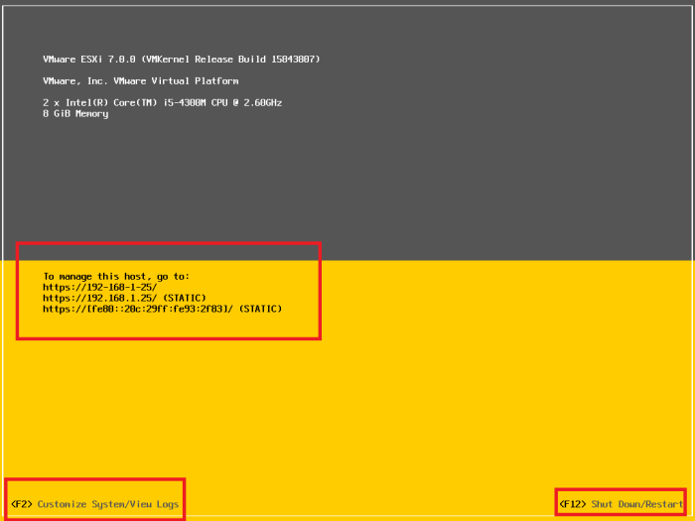

To configure the network and DNS the user must press “F2” which brings the user to customize the system which allows us to manage and configure different sections of the server as well as the network and DNS. The software will proceed and ask for password authentication for root and if there is no password configured yet. Users can just enter by pressing the “enter” key. The user is now brought into the system customization section in which we can configure different things including the network and DNS.

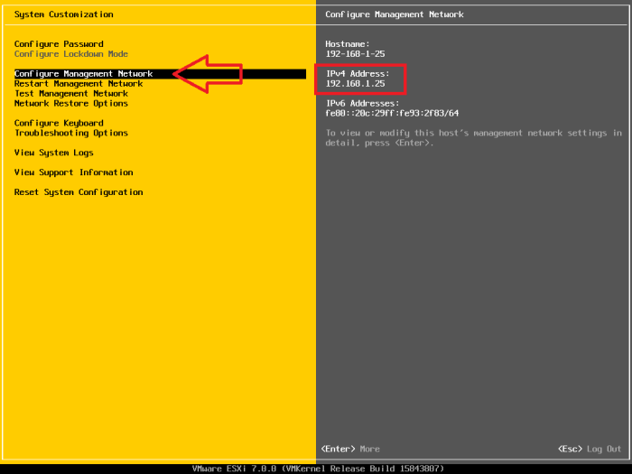

To configure the network and DNS users should click the “configure management network” to access the configuration of IP address and DNS. Under this section users can edit IPv4, IPv6, DNS, and Custom DNS suffixes. Our main concern is the IPv4 configuration and the DNS configuration. Under IPv4 configuration our professor in the lab proposed that we make the address “172.16.1.70 and 75” and set our subnet mask “255.255.255.0” and the default gateway is “172.16.1.1”, but if you have a desired setting then you can always change it under this section. If users already have a set IPv4 address, subnet mask, and default gateway then the configuration can be applied by clicking “enter” or “ok”. The next step is configuring the DNS server which is still under the “Configuring Management Network” section. In this section our professor proposed that we name our Primary DNS Server 172.16.1.1 same as the default gateway for IPv4 configuration, but in this section users can also change the hostname and if the user has a desired hostname and a different DNS server then this may be applied in this section.